[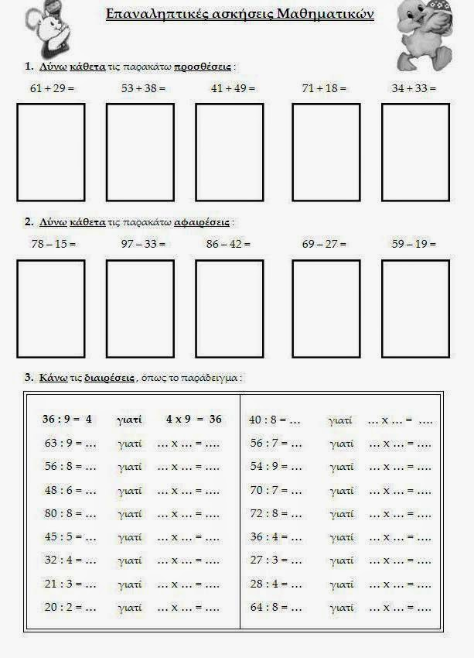](https://www.google.gr/url?sa=i&url=https%3A%2F%2Fe-didaskalia.blogspot.com%2F2014%2F04%2Fblog-post_2199.html&psig=AOvVaw2gYNs8aLj3acqmOpKpvN6y&ust=1584769559117000&source=images&cd=vfe&ved=0CAIQjRxqFwoTCKiYvfisqOgCFQAAAAAdAAAAABAI)